**2021 but it’s not our year so we aren’t (as) traumatised by it**

**2. b. i)**

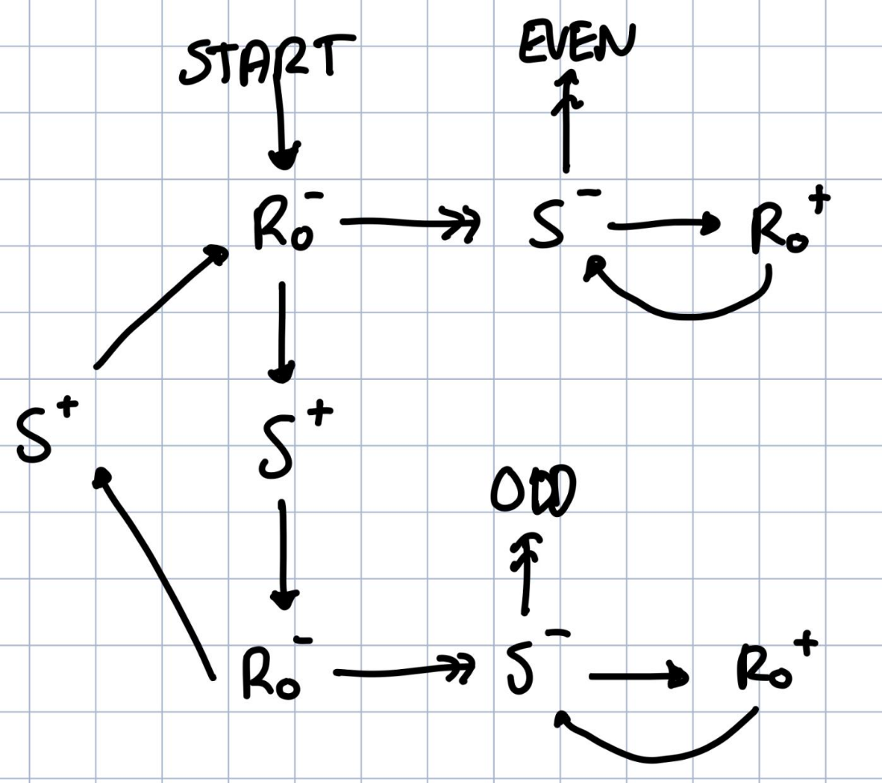

**2. b. ii)**

Sachin’s solution:

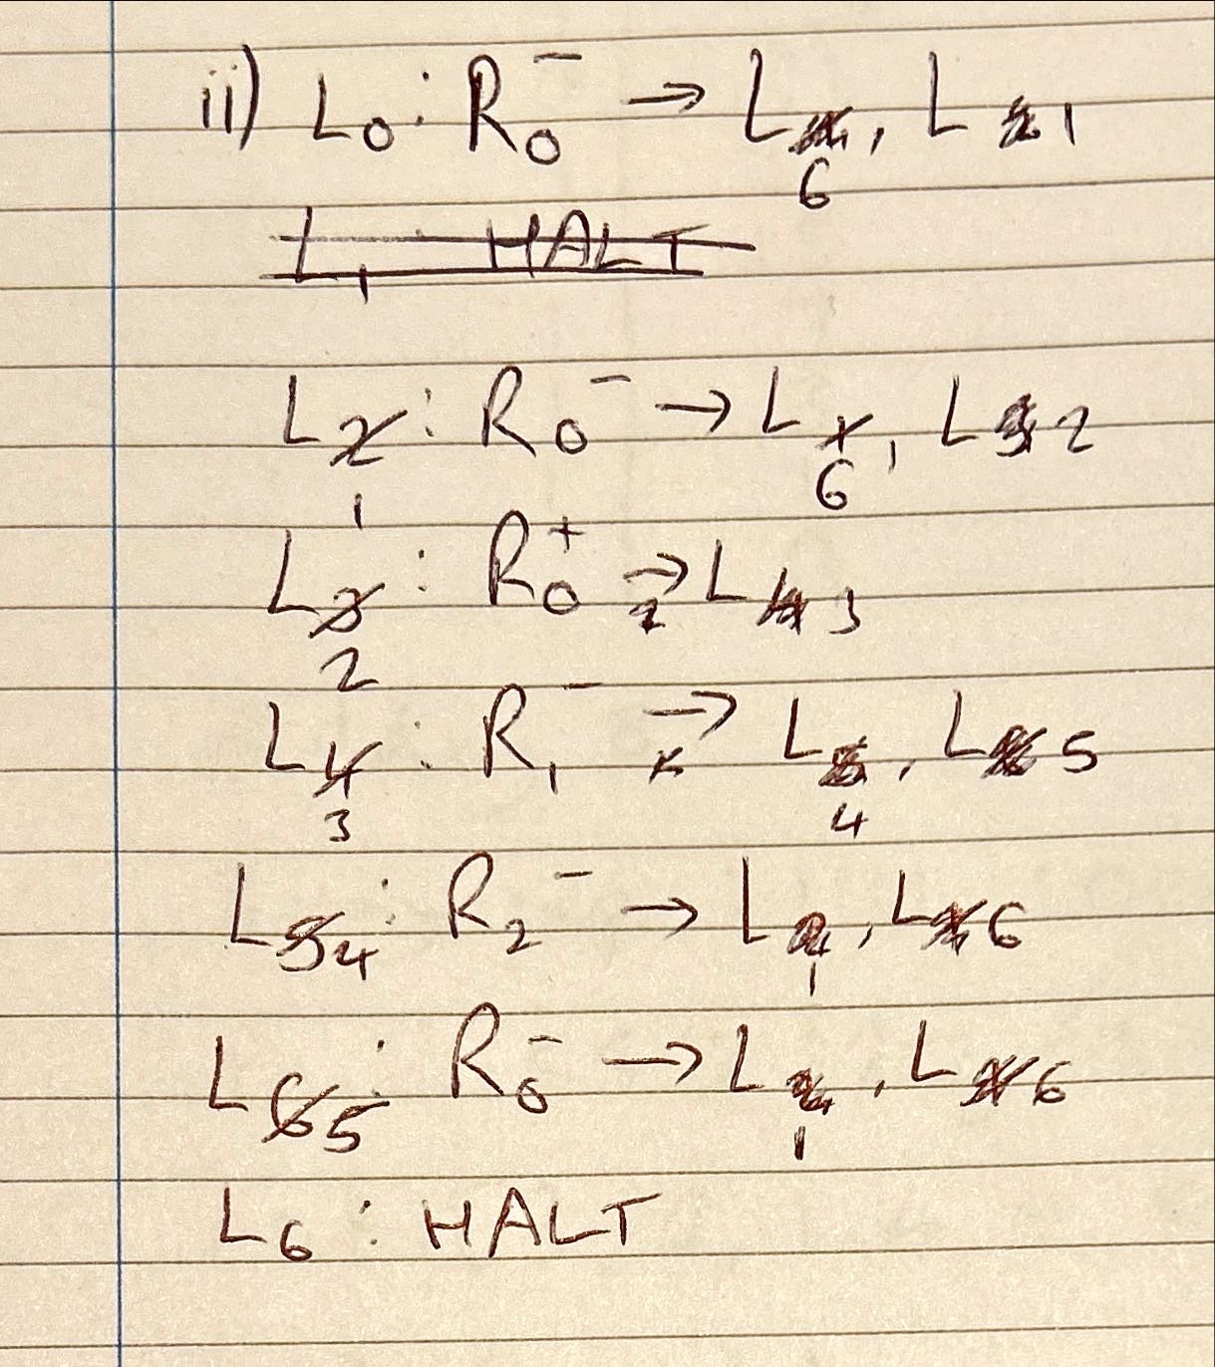

**2. b. iii)**

The register machine is computing the Collatz sequence from the starting value of R0. The Register Machine halts iff the Collatz sequence reaches 1. Except Herbert drew the register machine wrong and it is completely borked.

**2. b. iv)**

This shows that the Halting problem still applies to register machines, and we cannot know if the execution of a register machine will halt. If this was not the case, we would be able to determine whether the Collatz sequence would halt, provided that the given register machine halts iff the Collatz sequence halts.

**2. b. v)**

halve = λn . div n 2

triple = λn . plus 1 (mult n 3)

step = λ n . ifz (rem n 2) (halve n) (triple n)

collatz = Y (λ f . λ n . ifz (pred n) 1 (f (step n)))